

**Briefing Paper**

**Oxford City Council waste performance 2023 to 2024**

**Corporate Strategy**

Table of Contents

Oxford City Council waste performance 2023 to 2024 3

ORWP Engagement 3

Education and communication 4

Key Projects and Initiatives 5

Community Engagement and Support 5

Community Educational Events 5

Contamination Project 6

British Heart Foundation Pack for Good Campaign 6

City Food Waste Survey 6

Recycle Your Vapes Campaign 7

Podback Coffee Pod Recycling 7

Composting Events 7

Student Engagement – Oxford University and Oxford Brookes University 7

HRA Flats Project 8

Textile Recycling Pilot 8

Operational updates 8

Bulky waste collections 8

Waste reforms 8

Waste collaboration project 8

# Oxford City Council waste performance 2023 to 2024

1. In general, it has been noted that the trajectory is similar across the Oxfordshire Resources and Waste Partnership (ORWP) and nationally. Recycling rates for 2023/2024 saw notable peaks during April and May.
2. During December 2024 there is a decline in overall recycling percentage. This is mainly due to a decrease in garden waste tonnage compared to this time last year, due to the changes in weather.

Figure 1 – Oxford City Recycle Rates 2024/2025:

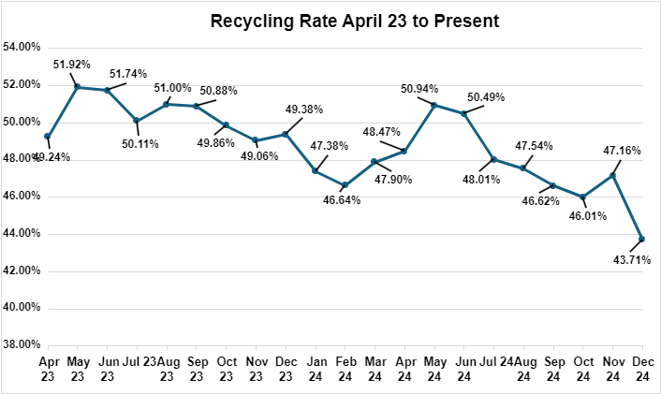

1. A growing focus on the circular economy is contributing to a shift towards sustainable waste management. This approach seeks to eliminate and reduce waste by fostering repurposing and resource efficiency.
2. Through practices such as sharing, repairing, refurbishment, remanufacturing, and recycling; Minimising resource consumption and reducing environmental impact. A good example of this is Oxford being recognised as the Freegle champion 2024, topping the charts for local reuse. ([www.ilovefreegle.org](https://eur01.safelinks.protection.outlook.com/?url=http%3A%2F%2Fwww.ilovefreegle.org%2F&data=05%7C02%7CMaria.Warner%40odsgroup.co.uk%7C9ac4d1d0e57d44b6f1de08dd34a2011a%7C9f3d0f395e2b4f889d43e9344f9aa02d%7C0%7C0%7C638724592576906712%7CUnknown%7CTWFpbGZsb3d8eyJFbXB0eU1hcGkiOnRydWUsIlYiOiIwLjAuMDAwMCIsIlAiOiJXaW4zMiIsIkFOIjoiTWFpbCIsIldUIjoyfQ%3D%3D%7C0%7C%7C%7C&sdata=u5WCJ9Spy1eRlWIJMdvT9TyWxFtLnvL4%2BIjnqffJK38%3D&reserved=0)).

# ORWP Engagement

1. The Council and ODS officers collaborate with the ORWP in all working groups on county-wide initiatives. Including strategic and operational as well as communication and education like the National Recycling Week and festive recycling campaigns. These initiatives focused on promoting recycling awareness and sustainable practices.
2. As part of these efforts, the Council and ODS engaged with over 400 children at Barton Farm Primary Academy and Our Lady’s Primary School through interactive assemblies promoting Recycling Week. Activities included discussions on the importance of reusing and recycling items, using games to help children learn how to correctly sort items for recycling.
3. As part of this initiative, children were invited to participate in Oxfordshire County Council’s Recycling Superhero Challenge, which the Council and ODS officers helped coordinate. Participants designed their own recycling-themed superheroes, with submissions sent to the County Council. Winners were randomly selected to receive prizes, including reusable water bottles. This initiative successfully combined education and creativity to inspire recycling awareness among young people and their families.

# Education and communication

1. The Recycling Team at ODS has undertaken a broad range of activities to promote recycling and reduce waste across Oxford.
2. These efforts include community engagement, school initiatives, waste reduction events, and specific projects targeting key waste streams.
3. This report outlines the team's achievements, focusing on behavioural change and improved waste management practices which have led to the team being shortlisted for two national awards from Keep Britain Tidy and the Local Authority Recycling Advisory Committee (LARAC).
4. The Council and ODS officers have continued efforts to tackle contamination and promote quality recycling through collaboration with crews and initiative-taking follow-ups on contamination reports; Through education, using face to face engagement and by providing a series of information leaflets, bin stickering advice, and house to house door knocking to raise awareness, and aims to ensure more ‘good recycling’ is presented.
5. Crews play a critical role in this effort by identifying and reporting contamination at the point of bin collection. This vigilance helps reduce contamination before it reaches the processing stage, ensuring higher recycling efficiency and minimising environmental impact.
6. The Council and ODS have noticed that the highest reported contaminates have been textiles and food waste, which helps us to focus attention when engaging with residents around these items.
7. Oxford operates a full mixed recycling collection service from all households, which includes all materials being mixed by citizens and collected either via individual households’ bins and bags, or communal larger wheeled bins fortnightly.
8. Contamination relates to the percentage of items in the mixed recycling that cannot be recycled at the Material Recovery Facility (MRF). It is important that only items that can be recycled are placed out for collection.

Figure 2 - Contamination Rates April 2023- December 2024:

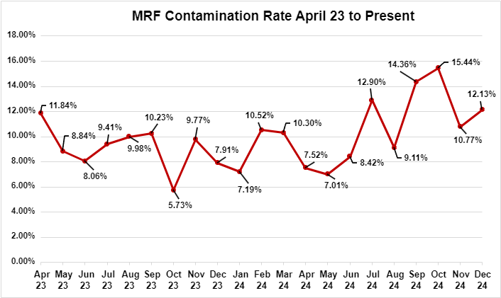

# Key Projects and Initiatives

### Community Engagement and Support

1. Recycling Officers have been active in the community, providing support to residents, schools, and event attendees. Their role focuses on educating residents about waste management, tackling contamination issues, and correct waste presentation.
2. On average, the team addresses 850 incidents monthly via in-person visits, emails, and calls, ensuring residents receive tailored advice to reduce barriers to recycling.
3. Through daily interactions with residents, Recycling Officers have reduced repeat contamination, enabling crews to service properties efficiently. Initiatives like the contamination project have further reinforced positive behavioural changes around waste management.
4. As part of this day-to-day work, Recycling Officers offer advice on how to cut down the amount of waste they are producing by helping them to better understand ways to recycle or donate items.
5. Residents are also encouraged to recycle food waste, by Recycling Officers helping them to understand any barriers they may have to doing this and supplying them with free food caddies.

### Community Educational Events

1. The Recycling Officers delivered 35 educational stalls, presentations, and training sessions across Oxford, promoting waste reduction and recycling. Highlights included a student-focused stall at Pembroke College, the Older People's Day event at the Oxford Town Hall, the Oxford Brookes University Science Bazaar, and electrical safety events at Rose Hill and Cutteslowe Community Centres.
2. They also attended Oxford Brookes Freshers week to help engage with students arriving to Oxford. The Recycling Officers try to engage with students early as many live away from Halls in year 2, so it helps to support students with a better understanding and good develop good habits early on.
3. These events featured interactive games, educational materials, and practical advice, with particularly high engagement during half-term weeks when family activities were planned.
4. At the Creative Lights Festival, a workshop hosted by Rosehill Community Centre, the Recycling Officers supported the week-long event, attending for three days.

### Contamination Project

1. As part of a contamination reduction initiative, the Recycling Officers visited 226 properties across the city over four weeks to address recycling issues reported by crews. Residents received personalised advice, information packs, and follow-up visits to tackle repeat issues.
2. After the initial engagement, only 26 properties required further follow-up, demonstrating the effectiveness of this targeted approach.

### British Heart Foundation Pack for Good Campaign

1. In partnership with the British Heart Foundation (BHF), ODS managed the Pack for Good campaign, targeting the collection and recycling of textiles from students and residents during student move-out periods. Temporary textile recycling banks were strategically installed to facilitate this initiative.
2. The student population and transient nature, impact on waste arisings in Oxford City. From April to August 2023, the campaign successfully diverted 14.34 tonnes of textiles from the waste stream. An extended initiative from April to October 2024 resulted in an additional 15.51 tonnes being collected.
3. The success of this campaign highlights its significant impact on reducing waste and its potential for broader adoption, including the development of a curbside textile recycling service to further enhance recycling accessibility and sustainability.

### City Food Waste Survey

1. During June – July 2024, Recycling Officers conducted a 16-day door-knocking campaign across Blackbird Leys and Cowley, surveying 2,026 households to address barriers to food waste recycling in these lower-performing areas. Of those approached, 435 residents participated in the survey, providing valuable insights into recycling challenges.
2. As a result of this engagement, 61% of participants committed to recycling food waste, with food caddies provided to support their efforts. This initiative exceeded the County’s key objectives by surpassing the target of 2,000 door knocks and achieving over 50% participation from residents willing to adopt food waste recycling.
3. Food waste is being monitored over time to see if there is any identifiable change or increase to food recycling as a result. The commitment is verbal initially, so remains to be seen how many residents sustain changed behaviour.

### Recycle Your Vapes Campaign

1. Launched in November 2023, the Recycle Your Vapes campaign, funded by Material Focus, addressed disposable vape waste by installing 38 vape bins across 17 locations in Oxford as part of a county-wide initiative. These included bins at pubs, cafes, bars, and Oxford Brookes campuses, as well as pink drop-off bins at all seven Household Waste Recycling Centres in Oxfordshire.
2. Collection rates increased significantly over time, with over 80,000 vapes collected during the campaign.
3. In addition to reducing hazardous materials as street litter, this initiative significantly lowered risks to staff, the public, and vehicles or equipment. Improperly disposed vapes can cause explosions when compacted in bins, posing safety hazards.

### Podback Coffee Pod Recycling

1. For three years, ODS has partnered with Podback to collect and recycle use plastic and aluminium coffee pods.
2. Over 28 million tonnes of waste have been diverted through the scheme already, with 3,500 households participating to date.
3. As one of the early adopters of this initiative, ODS continues to lead in promoting innovative recycling solutions.

### Composting Events

1. Two composting events were organised in Oxford, distributing 40-tonnes of nutrient-rich compost to the community for free, donated by Severn Trent Green Power.
2. In May 2023, 30-tonnes were provided to 23 local allotments, and in March 2024, 10 tonnes were distributed to approximately 500 residents. The compost, made from Oxfordshire's recycled food and garden waste, was processed locally in Wallingford.
3. These events aimed to promote sustainable practices, foster community engagement, and encourage residents to actively care for their environment.
4. For their impactful work on this project, the Council and ODS has been shortlisted for the Keep Britain Tidy Award for Community Engagement.

### Student Engagement – Oxford University and Oxford Brookes University

1. During Freshers' Weeks, Recycling Officers engage with students arriving in Oxford, educating them on recycling practices and local waste policies. This early outreach aims to instill sustainable habits that continue as students move from halls into the wider community.
2. Throughout the year, the team collaborates with Oxford Brookes University on initiatives such as litter picks, providing opportunities to engage with students and promote better recycling.
3. Door-knocking campaigns were also conducted in student-heavy areas, including Divinity Road, Bartlemas Close, and Gypsy Lane, offering advice and support to address waste issues, reduce contamination, and improve street cleanliness.
4. These efforts aim to reduce waste, increase recycling rates, and enhance the appearance of local streets.

### HRA Flats Project

1. Launched in August 2024, the HRA Flats Project is a trial that aims to improve recycling rates, increase food waste participation, and reduce overall waste at six HRA sites.
2. The initiative addresses recurring issues with shared bins, such as contamination, through a range of interventions, including door-knocking, leaflets, bin stickers, new signage, and relocating bins to more accessible areas.
3. Although the project is ongoing, early results indicate positive outcomes on some sites, the project will run for a minimum period of 6 months from inception, to get a fuller evaluation.
4. Initial data shows a decrease in contamination incidents reported by crews, reduced fly-tipping, and improved resident satisfaction based on mid-stage reviews in some areas, around the general appearance being improved in some areas.

### Textile Recycling Pilot

1. A new curbside textile recycling project is launching in February 2025, collaborating with an external partner. This pilot will include textile banks at Rosehill Community Centre and other locations in the future, alongside an online booking system for curbside collections.

# Operational updates

### Bulky waste collections

1. As of January 2025, ODS will increase the number of bulky waste collections they offer, as agreed by the Council’s Corporate Management Team. This will help to address the current backlog in the system and offer a following week collection service for new bookings.

### Waste reforms

1. DEFRA have continued work on the Simpler Recycling Reforms. In November 2024, all local authorities received a letter detailing proposed extended responsibility payment for household packaging in 2025/26. The Council and ODS have provided feedback to the notification.
2. ODS and the Council leads continue work to understand the implications and opportunities for recycling and waste services.
3. Currently all materials required for collection under the new legislation are offered, however further work is required into other potential options and methods.
4. This is a priority area of work and ODS have been assisting with information on waste compositional from households and litter analyses to assist DEFRA in data collection.

### Waste collaboration project

1. Work is underway to consider ways of collaborating more efficiently with our neighbouring authorities.
2. Earlier this year West Oxfordshire District Council, Cherwell District Council and Oxford City Council commissioned an independent specialist report to explore whether there would be a benefit to working in partnership. The County Council has now joined in with conversations around the proposals.
3. The report was triggered by the current waste contract in West Oxfordshire ending in 2026 which required a review of the service. The proposals will explore options of expanding upon the existing working arrangements.